# Database Design & ERD

The Entity Relationship Diagram (ERD) below illustrates the structure of the database for the E-Commerce system, defining the relationships between different entities.

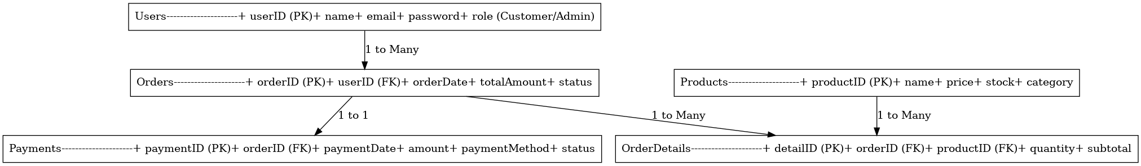

## Tables & Descriptions

### Users

Stores user information including login credentials and roles (Customer/Admin).

### Products

Stores product details like name, price, stock, and category.

### Orders

Represents customer orders, linking them to users and tracking order status.

### OrderDetails

Links products to orders, specifying the quantity and subtotal for each product in an order.

### Payments

Records payment transactions, including method and payment status.